**EF Task 1:**

1. Create a new Console Application.

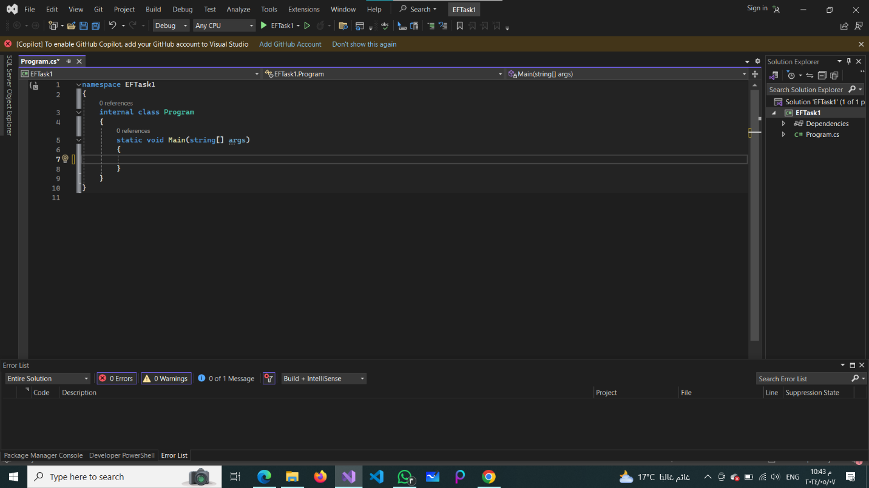

1. Install 3 Packages:

* Install EF Core package (Microsoft.EntityFrameworkCore).
* Install EF Core tools package (Microsoft.EntityFrameworkCore.Tools).
* Install EF Core SQL Server package (Microsoft.EntityFrameworkCore.SqlServer) for SQL Server database provider.

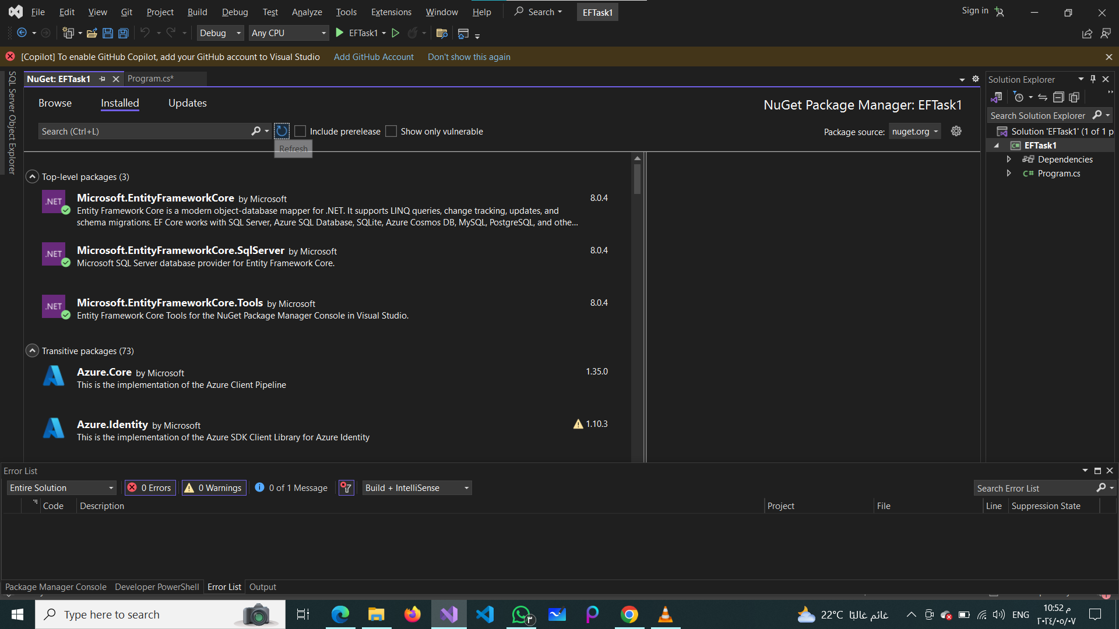

1. Application Db Context:

* Create an ApplicationDbContext class inheriting from DbContext.
* Define DbSet for the Taask entity.

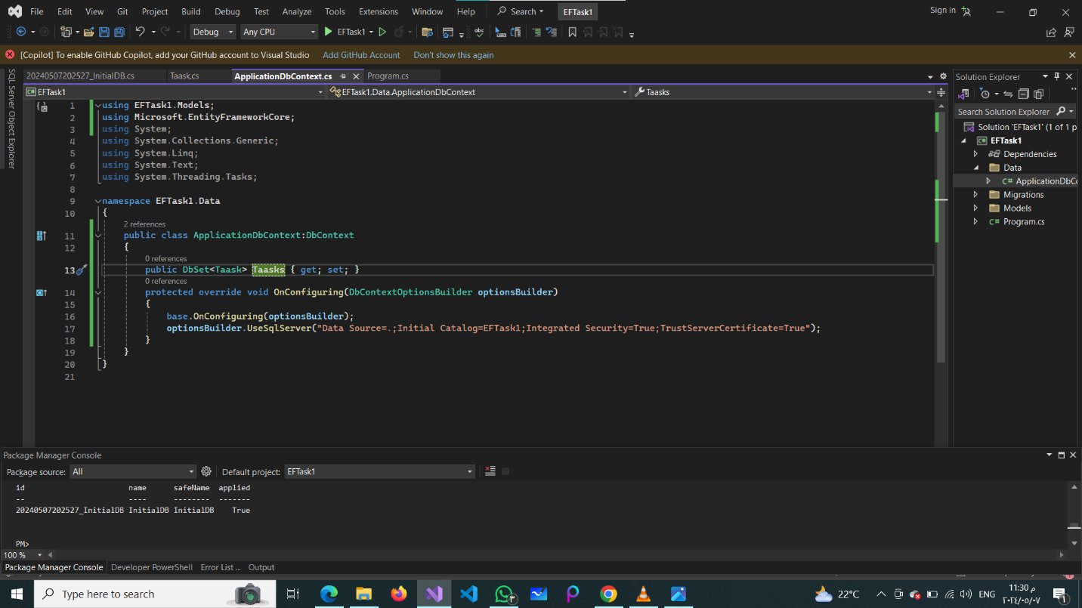

1. Taask entity contains (Id as int/ Title as string/ Description as string/ Date as DateTime).

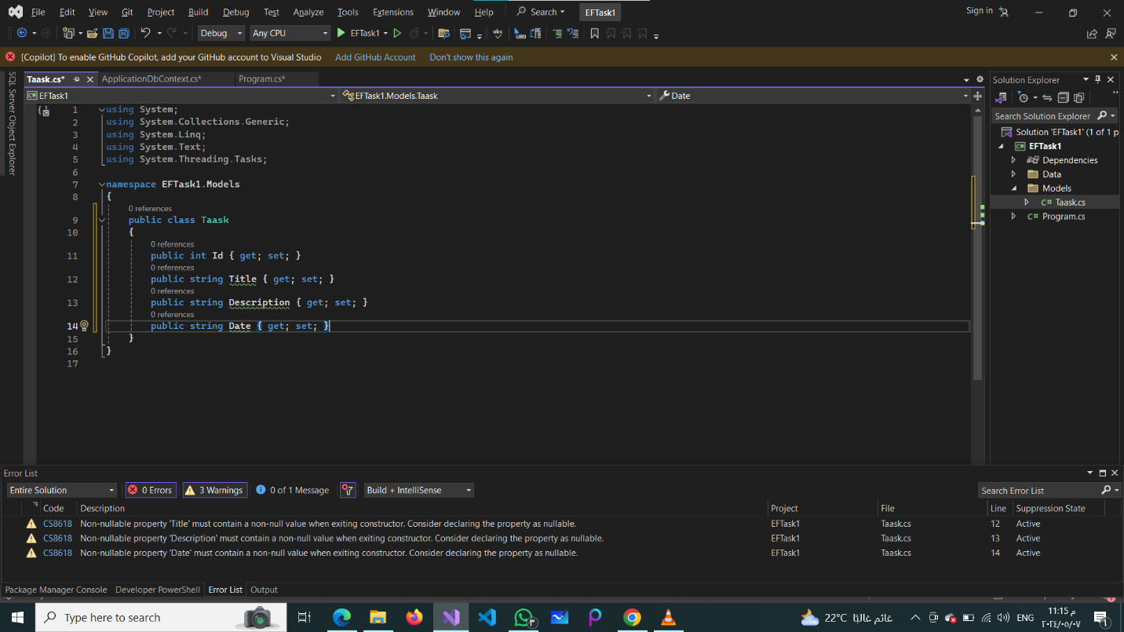

1. Migrations:

* Add a migration for initial database setup (Add-Migration InitialCreate).
* Update the database to apply the migration (Update-Database).

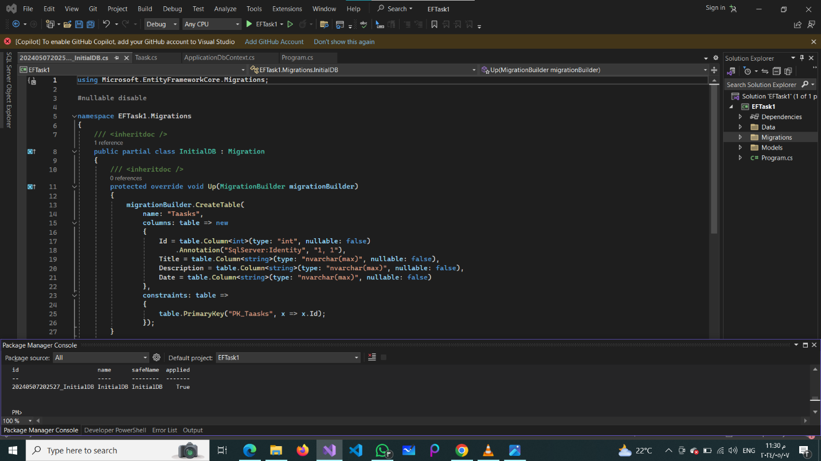

1. Use [Required] attribute to mark Title as required.

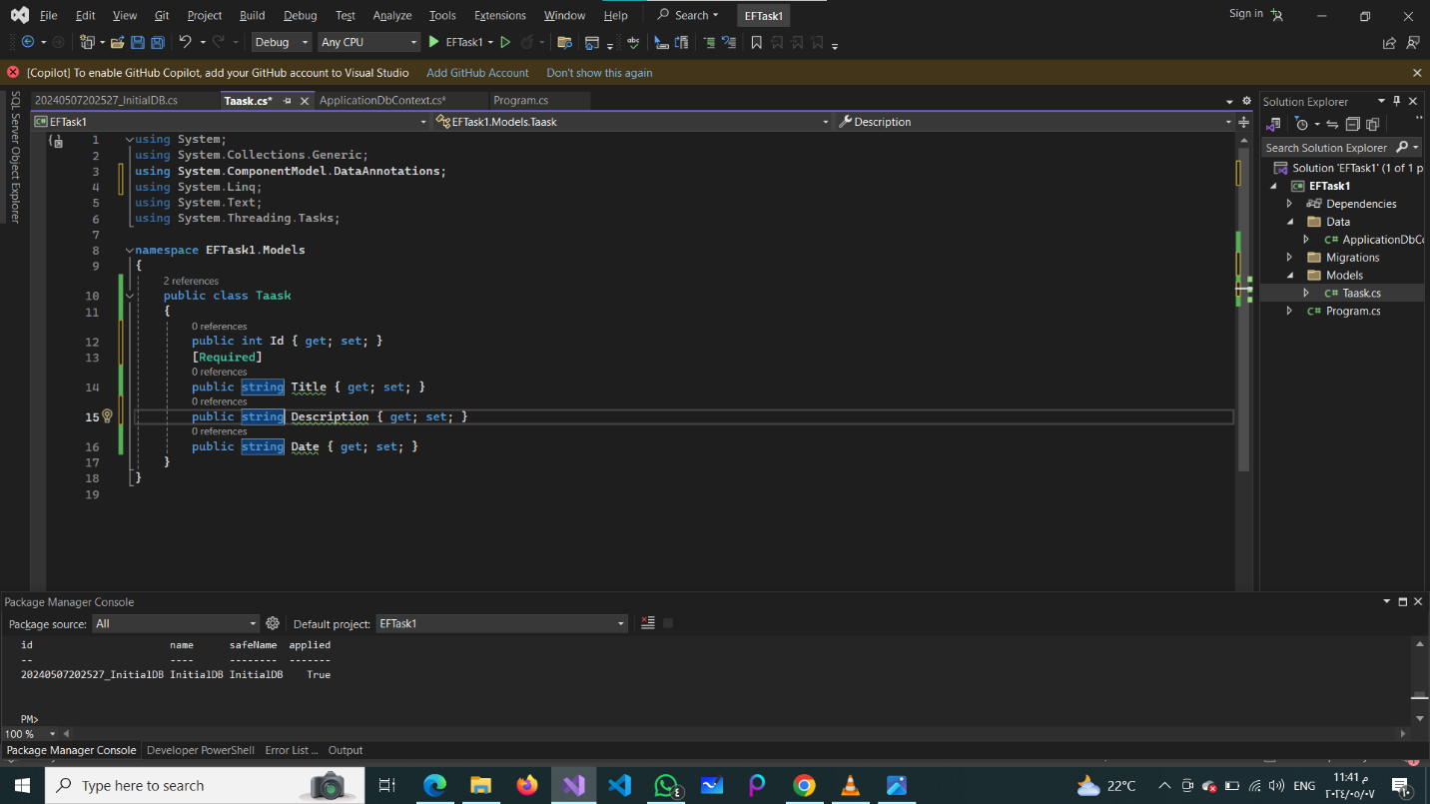

1. Use ? to mark Description column as non-required.

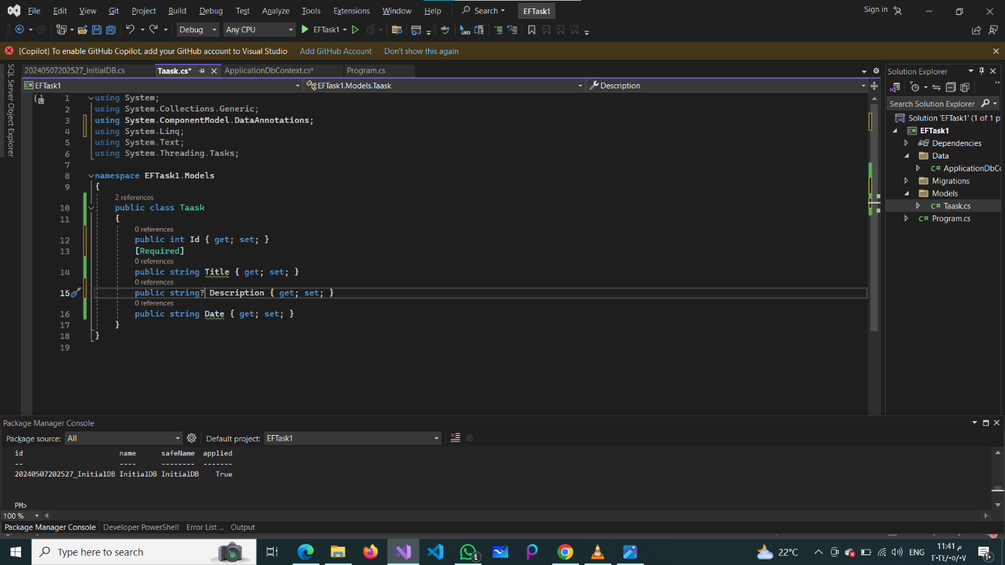

1. Change the table name for the Task entity using Fluent API to (NewTask).

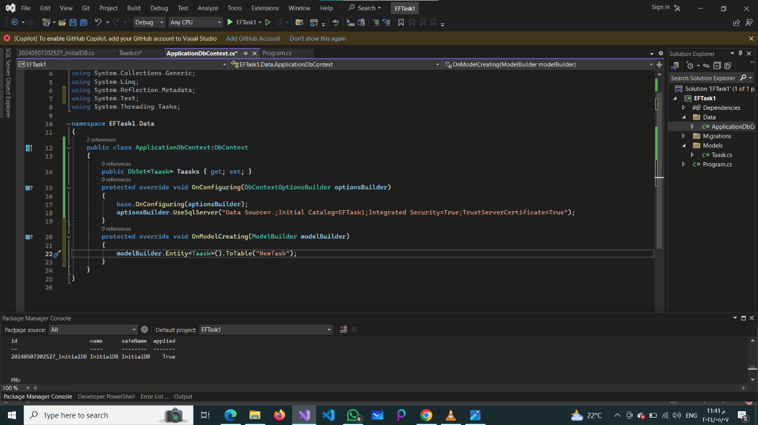

1. Change the column name for Date property to Deadline using Fluent API. (Search on it).

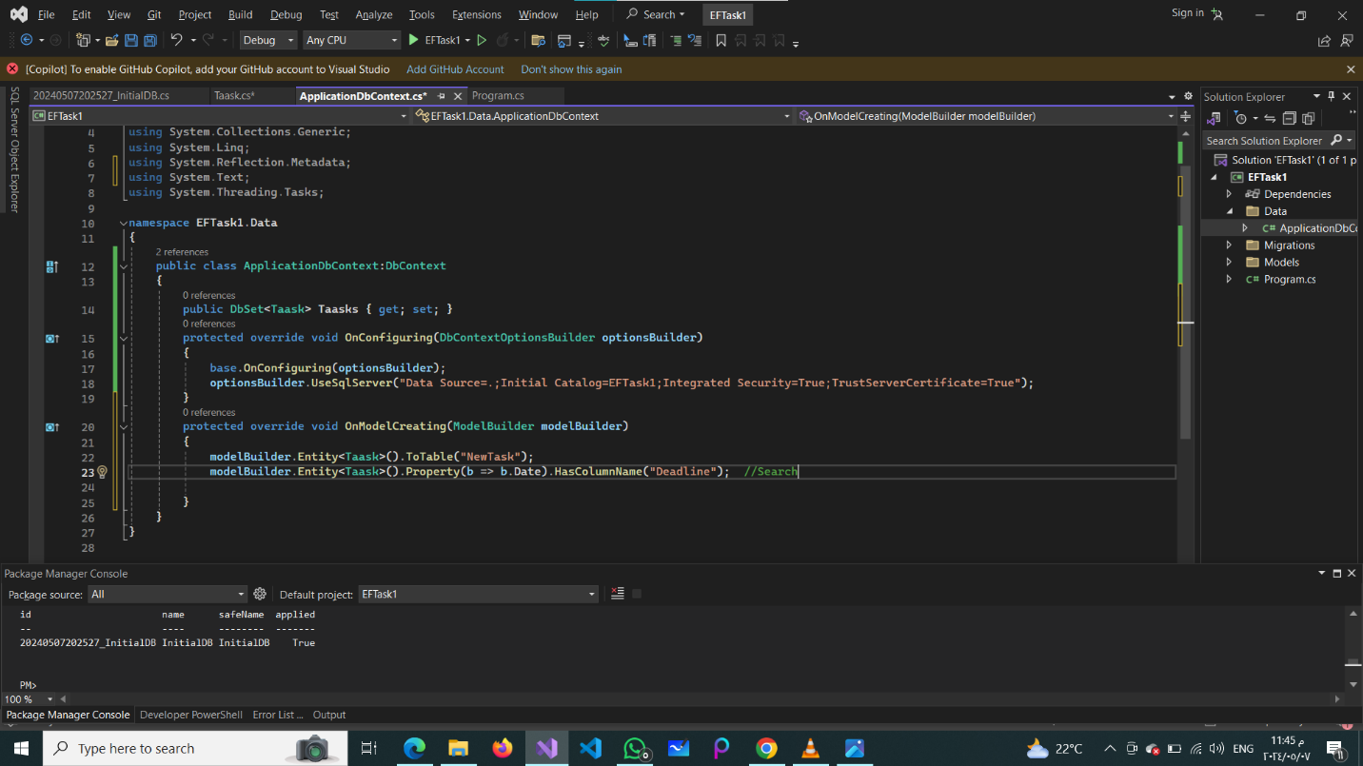

1. Create a new migration (Add-Migration UpdateTaskModel) and apply the migration.

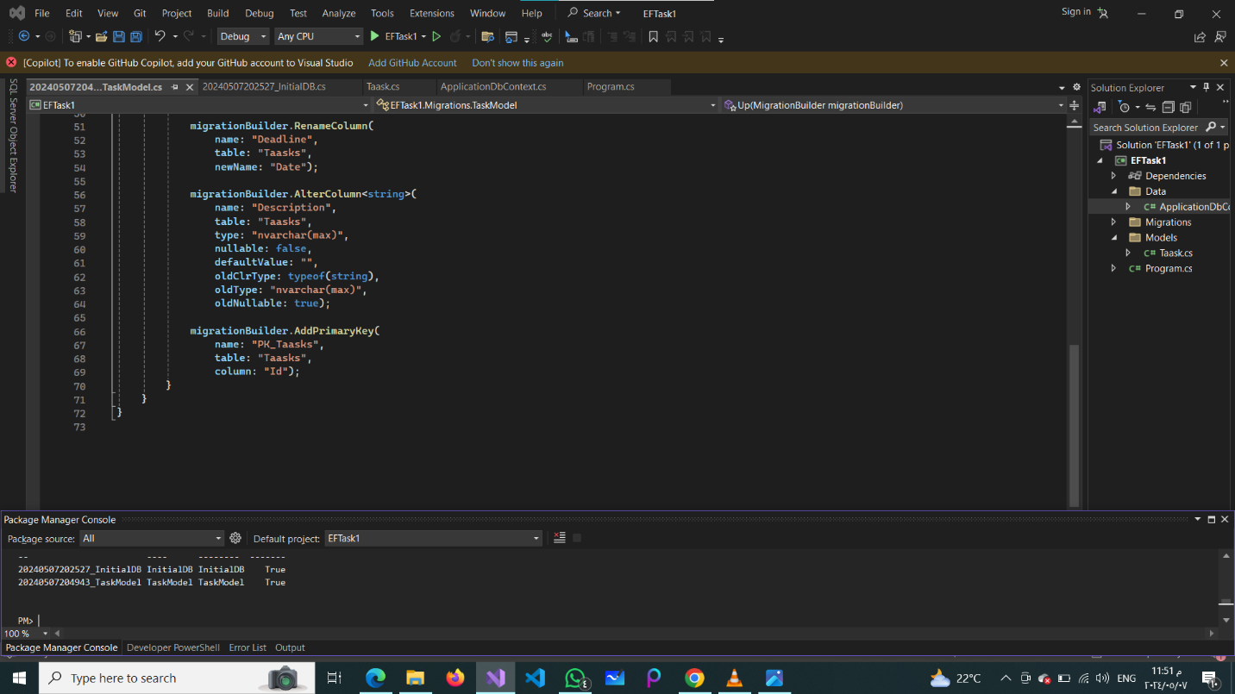

**Upload the project on GitHub and add the link.**